Digital Image Forgery Detection System using Deep Learning

A
Major Project
Submitted
in partial fulfillment
for award of the Degree of
Bachelor of Technology

In Department of Computer Science & Engineering

Supervisor Submitted By
Ms. Komal Paliwal Sujal Paliwal
Associate Professor Roll no: 22ESHCS019

Department of Computer Science Engineering
Shrinathji Institute of Technology & Engineering
Upali Oden, Nathdwara, Rajsamand
Rajasthan Technical University
April 2026

Candidate’s Declaration
I hereby declare that the work, which is being presented in the Project, entitled “Digital Image Forgery Detection System Using Deep Learning” in partial fulfillment for the award of Degree of “Bachelor of Technology” in Department of Computer Science & Engineering and submitted to the Department of Computer Science & Engineering, Shrinathji Institute of Technology & Engineering, Rajasthan Technical University, Kota is a record of my own investigations carried under the Guidance of Ms. Komal Paliwal, HOD CSE, Department of CSE, Shrinathji Institute of Technology & Engineering, Nathdwara.

ACKNOWLEDGEMENT
I sincerely thank my advisor, Ms. Komal Paliwal, HOD CSE, Department of CSE, for her patience, encouragement, and guidance to complete this dissertation. I appreciate her for his constant support. Ms. Komal Paliwal is always ready to answer my questions and inspire me whenever needed.

I am greatly indebted to Principal, SITE for their helpful guidance, suggestion and encouragement throughout my project work.
Finally, I would like to express my thanks to all other faculty members of Computer Science & Engineering Department, Shrinathji Institute of Technology & Engineering, Nathdwara for sharing good research ideas and suggestions. I pay my special thanks to management of college and all other staff members for supporting, guiding and encouraging me to complete this thesis.
I also appreciate colleges for sharing with me some wonderful time, helping me go through the hard times, and some of them being companions and fellow mothers with me. It would be a long list to mention all of the friends I am indebted to.
Finally, I would like to dedicate this project to my parent. Her love and encouragement were in the end what made this dissertation possible.
I thank almighty GOD who is behind me for providing the strength to carry my endeavor in good way.

TABLE OF CONTENTS

CONTENT | PAGE NO.
CHAPTER 1: INTRODUCTION | 1 – 5
1.1 Introduction | 1
1.2 Problem Statement | 2
1.3 Objectives | 3
1.4 Significance and motivation of Project Work | 3
1.5 Organization of the Project Report | 5
CHAPTER 2: LITERATURE SURVEY | 6 – 13
2.1 Overview of Relevant Literature | 6
2.2 Key Gaps in the Literature | 13
CHAPTER 3: SYSTEM DEVELOPMENT | 14 - 28
3.1 Requirements and Analysis | 14
3.2 Project Design and Architecture | 15
3.3 Data Preparation | 17
3.4 Implementation | 18

3.5 Key Challenges | 28
CHAPTER4: TESTING | 29 - 33
4.1 Testing Strategy | 29
4.2 Test Cases and Outcome | 32
CHAPTER 5: RESULTS AND EVALUATION | 34 - 41
5.1 Results | 34
CHAPTER 6: CONCLUSIONS AND FUTURE SCOPE | 42
6.1 Conclusion | 42
6.2 Future Scope | 42

CHAPTER 1: INTRODUCTION

INTRODUCTION

Detecting manipulations in digital images has become a critical concern due to the increasing sophistication of editing tools that challenge the reliability and authenticity of visual content. This project focuses on the implementation of a Convolutional Neural Network (CNN) based method to identify and locate manipulated regions within digital images accurately.

Due to the easy accessibility of image and video editing software, various forms of manipulations, such as copy-move, splicing, and retouching have emerged, posing threats to maintaining the credibility of visual content. Convolutional Neural Network (CNN) offers promise in this regard due to its ability to learn complex patterns and features, resulting in it being a good solution for detecting image forgeries.

In order to improve the performance of the CNN model various preprocessing techniques are employed. These techniques include reducing noise, resizing images and using augmentation methods. Additionally innovative approaches such, as incorporating loss functions and regularization techniques are implemented to prevent overfitting and enhance the model’s adaptability.

The main objective of this project is to contribute to the advancement of image forensics by introducing a methodology based on CNNs. This methodology aims to detect and locate forged regions within images. By doing it seeks to strengthen trust and credibility in media by safeguarding against falsified or misleading visual content. Through the use of techniques this project aims to address the challenges posed by image manipulation and provide a solution for ensuring the integrity and authenticity of visual information.

PROBLEM STATEMENT
In today’s digital era, image forgery has become a major challenge due to the ease of manipulating photos using advanced editing tools. With the widespread use of social media, online journalism, and digital communication, it is essential to develop reliable methods to detect forged images. The rise of misinformation makes it difficult to distinguish between authentic and manipulated visuals, raising concerns about the credibility of digital content.
The key challenge is to design efficient systems that can accurately identify and classify altered images while differentiating them from genuine ones. These systems must handle various types of manipulations such as copy-move, splicing, and retouching across different formats, resolutions, and platforms. This requires the use of advanced techniques like computer vision, machine learning, and deep learning to not only detect forgeries but also analyze the methods used.
Addressing this problem is crucial for maintaining the integrity of visual information. Effective forgery detection solutions can help individuals, organizations, and platforms rely on authentic content, reduce the spread of misinformation, and ensure trust in digital media.

OBJECTIVES

    - Developing a Convolutional Neural Network (CNN) Model for Copy-Move Forgery Detection.
    - Developing a Convolutional Neural Network (CNN) Model for Splicing Detection.
    - Development of a User-Friendly Web-Interface Integrated with the Trained Model

SIGNIFICANCE AND MOTIVATION OF THE PROJECT WORK

Significance
- Combating Misinformation: Helps detect fake and manipulated images, reducing the spread of misleading content and fake news.
- Protecting Image Integrity: Ensures authenticity of visual data in fields like journalism, healthcare, advertising, and research.
- Building Trust: Promotes reliability and transparency in digital media, increasing user confidence in visual content.
- Driving Innovation: Encourages advancements in image analysis and forgery detection technologies to tackle evolving manipulation techniques.

Motivation –
- Mitigating Misinformation: Helps combat fake news and misleading visuals by detecting manipulated images.
- Preserving Authenticity: Ensures credibility of digital media in fields like journalism, healthcare, and advertising.
- Supporting Forensic Analysis: Assists investigators and law enforcement in verifying the authenticity of visual evidence.
- Enhancing Trust: Builds confidence among users by distinguishing real images from fake ones.
- Driving Innovation: Promotes advancements in image processing and detection technologies.

ORGANIZATION OF PROJECT REPORT

The report is organized as follows –
Chapter 1 presents us with the introduction of image forgery, along with the problem statement, objectives, significance and organization of the project.
Chapter 2 outlines the existing related works in the domain of image manipulation detection, further providing the outputs of their analysis which is compared and used in the project.
Chapter 3 introduces the model that has been trained and tested to detect forgeries in digital images. This is the chapter that includes the requirements, analysis, the project design and its architecture and the implementation of the project.
Chapter 4 delves in the training and testing phase, by examining datasets, experimental setups and both qualitative and quantitative results obtained from the model all the while assessing model performance.
Chapter 5 examines the image forgery detection outcomes and the overview of the experimental setup.
Chapter 6 presents the conclusion of the study along with future scopes of the project.

CHAPTER 2: LITERATURE SURVEY

OVERVIEW OF RELEVANT LITERATURE
Image forgery detection focuses on identifying manipulated digital images. Traditional methods include passive techniques (analyzing noise, compression artifacts, and inconsistencies) and active techniques (watermarking and digital signatures). Common manipulations are copy-move, splicing, and retouching.
With technological advancements, deep learning—especially Convolutional Neural Networks (CNNs)—has significantly improved detection accuracy. Approaches like Siamese networks, GAN-based methods, and transfer learning help extract meaningful image features. Popular datasets include CASIA, NIST, and COVERAGE, though challenges like dataset bias and lack of standard evaluation remain.
Deep learning models have shown strong results, with ELA-CNN achieving up to 99.87% accuracy and other CNN models reaching 92–97%. However, detecting advanced manipulations such as DeepFakes remains challenging, with lower accuracy. Other methods like IRVM and VGG-based models also perform well in detecting splicing and compression artifacts.
Despite progress, challenges like robustness, scalability, and real-time detection persist, especially with increasingly realistic GAN-generated forgeries. Ethical concerns, including misuse and privacy, further emphasize the need for responsible development.
In conclusion, while significant progress has been made, ongoing research is essential to improve accuracy and address emerging challenges in image forgery detection.

KEY GAPS IN THE LITERATURE

    - Limited Training Data: Many studies highlight the challenge of limited data for training deep neural networks, which can hinder the performance and generalization of models.
    - Model Performance on Small Images: Some models do not perform well on tiny images, indicating a need for improvement in handling small-scale images.
    - Variability in Performance Based on Dataset Size: The performance of forgery detection models may vary depending on the size and quality of the dataset used for training and evaluation.
    - Limited Discussion on Experimental Results: Some studies provide limited discussion on the experimental results, making it challenging to assess the reproducibility and reliability of the proposed methods.
    - Limited to Specific Datasets: Some approaches are limited to specific datasets, such as the MICC-F220 dataset, which may restrict their applicability to other datasets or real-world

CHAPTER 3: SYSTEM DEVELOPMENT

REQUIREMENTS AND ANALYSIS
Following are the requirements to run the project without any system errors or issues:

SOFTWARE REQUIREMENTS
The project has the following software requirements –
- Programming Language: Python 3.3 or higher
- Integrated Development Environment (IDE): Visual Studio Code (VS Code), Jupyter Notebook

HARDWARE REQUIREMENTS
The project has the following hardware requirements –
- Random Access Memory (RAM): 8 GB or higher
- CPU Requirements: 1.6 GHz
- Operating System: Windows

LIBRARY REQUIREMENTS
- Numpy – Numpy is a fundamental library for numerical computations and handling array operations, especially in image processing tasks.
- OpenCV – It is used for image processing tasks like filtering and resizing images.
- Streamlit – It is used to create the web application interface for uploading images and displaying the results of the forgery detection model.
- Tensorflow – Tensorflow is utilized for deep learning tasks.
- Matplotlib – It is used to visualize images, ELA results, and performance graphs during model training.
- PiL (Pillow) – It is Employed for image processing tasks like ELA, image manipulation.

PROJECT DESIGN AND ARCHITECTURE

- The Convolutional Neural Network (CNN) model (Fig 1) used in this study is based on the CASIA 2 dataset, a well-known benchmark dataset in the field of image manipulation detection. The dataset contains a vast collection of both original and altered photos, making it ideal for training and testing the model's performance.
- Before feeding the images into the CNN model, numerous preprocessing processes are used to improve the data's quality and compatibility.
- Image Resizing: The images in the CASIA 2 dataset vary in size, which can impair the model's performance. To remedy this, all photos are downsized to a common size (e.g., 256x256 pixels) using interpolation techniques that maintain the aspect ratio.
- Feature Selection: In addition to scaling, various feature selection techniques can be used to extract useful information from photos. This can include approaches like histogram equalization, which increases image contrast and allows the model to recognize minor variations between legitimate and altered photos.
- These preprocessing processes serve to prepare the dataset for training the CNN model, guaranteeing that it can learn and identify patterns associated with picture counterfeiting.

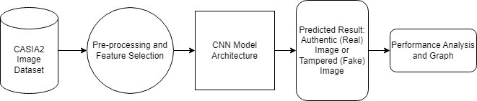

Fig 1: Project Design

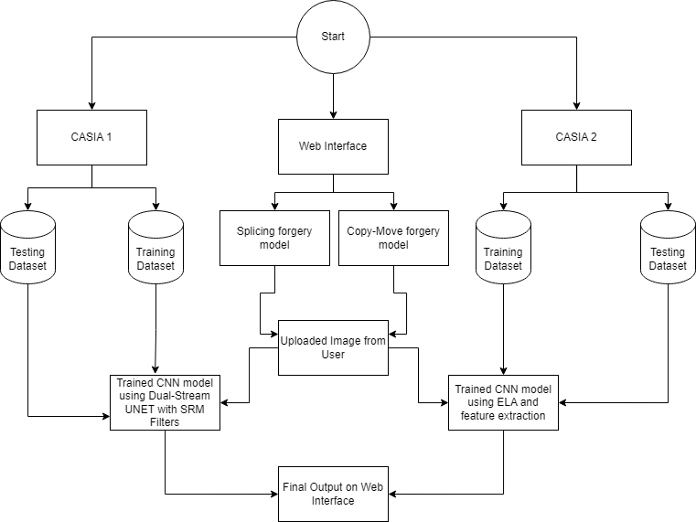
Fig 2: Project Architecture

- CASIA 1 dataset (Fig 2) is used to train and test the Splicing CNN model. A Dual-Stream UNET architecture is adopted for the second phase of Splicing forgery detection. The architecture consists of two streams: The first one is for processing the RGB images and the second one is for processing a noise feature map generated by passing the image through SRM (Steganalysis Rich Model) filters. The output from both the streams is then integrated and passed through a CNN layer with a sigmoid activation function in order to produce a binary image which will indicate all the manipulated regions in the input image.
- A combination of Error Level Analysis (ELA) and Convolutional Neural Network (CNN) is used along with CASIA 2 dataset to train and test the Copy-Move model. Based on the differences in the compression levels, ELA is used to identify the regions of an image that may have been altered.

DATE PREPARATION

DESCRIPTION OF THE DATASET
This project requires a large number of images, consisting of both forged and authentic images which will be used to train te model. For this purpose, CASIA2 [26] dataset is being used which is readily available on Kaggle.
It consists of a total of 12,000 images with around 7000 of them being authentic images and around 5000 tampered images.

There are four folders in the dataset, namely –
- Tp – This folder contains the fake copy-move images
- Sp – This folder contains the fake spliced images
- Au – This folder contains all the real images
- CASIA 2 Groundtruth – This folder contains a fake image mask

DATA CLEANING AND PREPROCESSING
The dataset underwent several preprocessing steps to standardize the images for Copy-Move model training:

- Image Resizing: All images were resized to a uniform size of 128x128 pixels using bicubic interpolation to maintain image quality.
- ELA Image Generation: Error Level Analysis (ELA) images were generated for each original image in the dataset, aiding in identifying potential manipulations and compressions.
- ELA Image Generation: Error Level Analysis (ELA) images were generated for each original image in the dataset, aiding in identifying potential manipulations and compressions.
- As for the Splicing model training, the dataset underwent the following preprocessing steps:
Image Resizing: The RGB images were resized to 512x512 pixels to match the input size expected by the dual-stream UNET model.
- Data Splitting: The dataset was split into training and validation sets of 80% and 20% to evaluate the performance of the model.

IMPLEMENTATION

COPY-MOVE FORGERY DETECTION MODEL
System Overview – Currently, CASIA1 and CASIA2 datasets are being utilized, both of these datasets are available on Kaggle for the project. The task is divided into two phases. Initially, the goal is to classify images as either real or fake, constituting a classification problem. Subsequently, in the second phase, the aim is to predict the tampered regions within the images, resembling a Binary-Image Segmentation problem. While there is no strict latency requirement for immediate results, it is essential that the model does not take an excessive amount of time to determine both the authenticity of the image and identify the tampered regions.

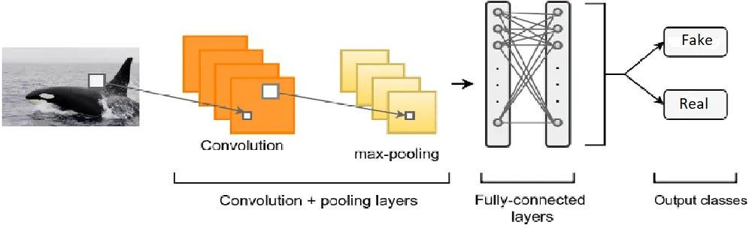
Fig 3: Copy-Move model architecture [18]

PHASE 1
In phase 1, the model aims to predict whether an image is real or fake, which is a classification problem. The model architecture is shown in Fig 3.

DATA EXPLORATION
        - Begin by importing fundamental Python libraries for tasks such as data exploration, manipulation, and model development.
        - Within the dataset, there are three distinct folders: Tp, CASIA2 Groundtruth, fake images

        - To initiate the analysis, the main focus will be on fake images housed in the 'Tp' folder. As this directory also contains miscellaneous files, only those files with the extensions '.jpg' or '.png' will be specifically read and considered.

There are a total of 2064 fake images in the dataset as shown in Fig 4, each associated with a corresponding mask image stored in the 'CASIA 2 Groundtruth' folder, indicating the tampered regions. However, it’s important to note that this mask information is not needed in the phase 1 of the analysis.

The count of authentic (real) images is 7437 as shown in Fig 5, a substantially larger number compared to fake images, posing the challenge of an imbalanced dataset. To address this issue, a technique known as under sampling will be employed, reducing the number of pristine images. As a result, an almost balanced dataset of images is achieved belonging to both the fake and real classes, totaling half of the original dataset.

DATA PREPROCESSING
The approach involves conducting an error level analysis on the input image and feeding the resulting Error Level Analysis (ELA) to a simple convolutional neural network (CNN) trained to discern between fake and authentic images. Error level analysis is a method for detecting manipulated images by capturing them at a specific quality level and subsequently calculating the variation from the compression level. When an image is initially saved as a JPEG, it undergoes compression. Most editing software, such as Adobe Photoshop, GIMP, and Adobe Lightroom, supports JPEG compression operations. If the image is then modified using editing software, it is compressed once again. Neal Krawetz introduced the concept of Error Level Analysis for images after observing how errors propagate during the saving of a JPEG image, especially when sections are cut out and the image is subsequently compressed. of an image and pasting it into another image, the ELA for the pasted section often detects a more

        - Function for generating ELA image of an input image.
        - A function is defined that will generate an ELA image for an image plus it will normalize the pixel value of the ELA image (from 0–255 to 0–1). It will also resize the image to 128*128.
        - It is then iterated over the dataset to generate X (input) and Y (output). X contains a 128*128 long vector and Y is the corresponding label for that X (0 for fake and 1 for real)
        - Next, the data is separated (X and Y) into training and validation sets. A testing set will not be built as there are not enough data points available.
        - A custom data generator is built so that there is no need to preprocess all the data points at a time and store them in the RAM. A batch of data points can be preprocessed and passed through Convolution Neural Network.

MODEL BUILDING AND TRAINING

        - A simple neural network is made with 2 convolution layers with a max pooling layer and a dropout layer followed by two dense layers and one output layer. The model has a total of 4194320 parameters
        - The model is compiled with Adam (learning rate=0.0001) as optimizer and binary cross entropy as loss function because there are only two classes.
        - Two callbacks are defined (A callback is a set of functions to be applied at given stages of the training procedure. It is defined and used when there is a need to automate some tasks after every training/epoch that helps you have control over the training process).

        - The Structure of the copy-move forgery detection CNN model
        - LearningRateScheduler It will decrease the learning rate by 10 percent after every 5 epochs.
        - Early stopping – It will monitor validation loss, if it doesn’t decrease after 3 epochs it will stop the training model.

PHASE 2
In the second phase, the main objective is to predict the specific region of a manipulated image where tampering has occurred. This task essentially boils down to a binary image segmentation problem. The input to the model is a forged image, and the desired output is a binary image that highlights the areas where tampering has taken place.

DATA EXPLORATION
        - Importing essential libraries for data manipulation and constructing a deep learning model.
        - In this context, manipulated images will be exclusively utilized, and for these corresponding masks are provided. These masks delineate the specific regions within the images that have undergone tampering. So essentially, the process involves reading each file individually and extracting the image path, assigning a label (in case, "fake"), and creating an image ID.
        - For every manipulated image, there is a corresponding mask image. Iterations will be run through the CASIA 2 Groundtruth folder in the dataset (Fig 8), which contains all the mask images. During this iteration, the image ID and the path of the respective mask image will be recorded

Now there are two datasets, one contains a fake image path and image ID second contains a mask image path and image ID. So, the idea is to merge both of them (on image id) into one which contains the image path and mask image path.

DATA PREPROCESSING
        - In the image forgery detection process, a crucial step involves modifying the mask image to distinguish between tampered and non-tampered regions. This modification is achieved by representing the tampered region as black and the non-tampered region as white, as illustrated in Fig 10. Initially, the mask image contained pixel values ranging from 0 to 255. To ensure compatibility with the sigmoid activation function used in the output layer of the model, these values are scaled down to either 0 or 1. Specifically, all pixel values that were originally 255 (representing white) are converted to 0.0 (black), while pixel values that are not equal to 255 are converted to 1.0 (white). This transformation allows the model to interpret the mask image accurately and make informed decisions regarding the authenticity of the input image.

        - The scaling of pixel values in the mask image is critical for the proper functioning of the model's output layer. The sigmoid activation function, commonly used in binary classification tasks, expects input values to be within a certain range (typically between 0
and 1). By converting the pixel values in the mask image to 0 or 1, the sigmoid function can effectively process this data and generate meaningful predictions. This step ensures that the model can accurately differentiate between tampered and non-tampered regions based on the information provided by the mask image, ultimately improving the overall performance and reliability of the forgery detection system.

        - The Dataset (fake image data) is then split into training and validation datasets.
        - For this task, a dual-stream UNET will be used. The first stream input will be the RGB image second stream input will be a noise feature map which will be obtained by passing the image through SRM (Steganalysis Rich Model) filters.
        - The Precision, Recall and F1-Score can be calculated from the code.

SPLICING DETECTION MODEL
- The ELA Image Generation Function is a code segment that defines a function named 'convert_to_ela_image'. This function takes two inputs: the path to an image file and the quality level for resaving the image. The function then executes a series of operations to create an ELA (Error Level Analysis) image based on the input image. ELA images are useful in detecting image manipulations because they highlight areas of an image that may have been altered or compressed differently from the rest of the image. By resaving the image at a specified quality level and comparing it to the original, ELA images can reveal discrepancies that indicate tampering or manipulation.
- In the data preparation step, the input images are converted into ELA images using the 'convert_to_ela_image' function. These ELA images are then resized to a standard size of 128 x 128 pixels. This resizing is crucial for standardizing the input images, ensuring that they are all the same size and format before being processed by the splicing detection model. Standardizing the input images in this way helps to improve the efficiency and accuracy of the model, as it reduces the variability in the input data and ensures that the model is trained on a consistent set of images. The original image and the image after conversion to ELA is shown in Fig 12.

KEY CHALLENGES
- Since, it is a CNN it requires a heavy computational power to train the model and with the use of more and more big dataset consisting of more images there is a need for a heavy GPU enabled machine to train it efficiently and faster.
- Ensuring that the models generalize well to unseen data and can detect a wide range of image manipulations effectively can be challenging.
- Detecting complex manipulations such as splicing and retouching can difficult to identify.
- Handling noise and distortion in images can affect the model's ability to detect forgeries accurately.

CHAPTER 4: TESTING

Following the successful training of the models, the testing and validation phase will begin by evaluating the models’ performance on randomly selected photos from the dataset.

TESTING STRATEGY
Testing strategy of both the models are described below:

COPY-MOVE FORGERY DETECTION MODEL

been digitally manipulated by comparing the original image to a re-saved version with a different compression level. The function accepts an image file path and a quality argument as input. It creates a temporary JPEG version of the image and then calculates the difference between the original and temporary images to identify areas of substantial variation. Finally, it increases the brightness of the difference image to highlight the altered regions before returning the final ELA image.

This code sample (Fig 14) provides the function “prepare_image”, which turns an input image to an Error Level Analysis (ELA) image, resizes it to 128x128 pixels, flattens it into a NumPy array, and normalizes the pixel values to a range of 0 to 1.

In this snippet (Fig 15), the test image is first prepared by converting into ELA image and getting resized, after that getting the prediction for the test image using the trained model.

In this snippet 5 random images are selected from the dataset and are sent to predict function to get the prediction of whether they are fake or authentic.

SPLICING FORGERY DETECTION MODEL
This function “preprocess_image” (Fig 18) loads an image from the specified location and resizes it to 128x128 pixels using Keras' image.load_img method. It then converts the image to a NumPy array, increases its dimensions to match the desired batch size (adding a dimension at axis 0), and divides the pixel values by 255.0 to normalize them to a range of 0 to 1. The processed picture array is returned for future usage in a model.

A custom input image is used in Fig 18, which is then fed to the trained model to predict whether it is fake or authentic.

TEST CASES AND OUTCOMES
While classifying for the 5 random images to test the model trained for copy-move forgery detection, it classified all the 5 images correctly. As shown in Fig 19.

CHAPTER 5: RESULTS AND EVALUATION

RESULTS
The combination of both models produced an image forgery detection system capable of identifying two different types of image modifications with high accuracy. The splicing forgery detection model, which used a Dual-Stream UNet architecture with SRM filters, along with copy-move forgery detection model which used ELA-CNN will be validated after successful training of both the models in order to see how they are performing on the testing dataset.

COPY-MOVE FORGERY DETECTION MODEL
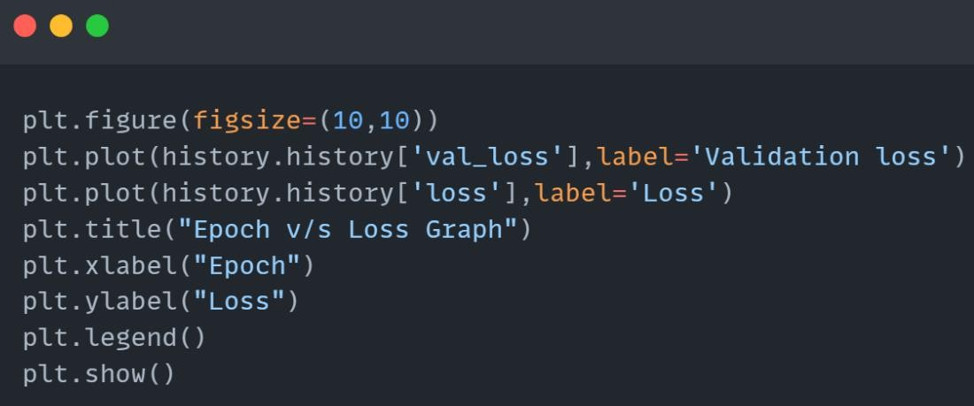

Fig 21: Plotting the model loss

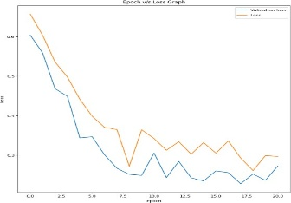
In this snippet (Fig 21), Epoch v/s Loss graph is being plotted (Fig 22). Here, in this graph, it illustrates how the loss of the model changes over the epochs during the training process. The loss represents the difference between the predicted output of the model and the actual ground truth of truth labels. The y-axis having lesser values indicates better performance over the epochs.
Fig 22: Epoch v/s Loss graph

SPLICING FORGERY DETECTION MODEL

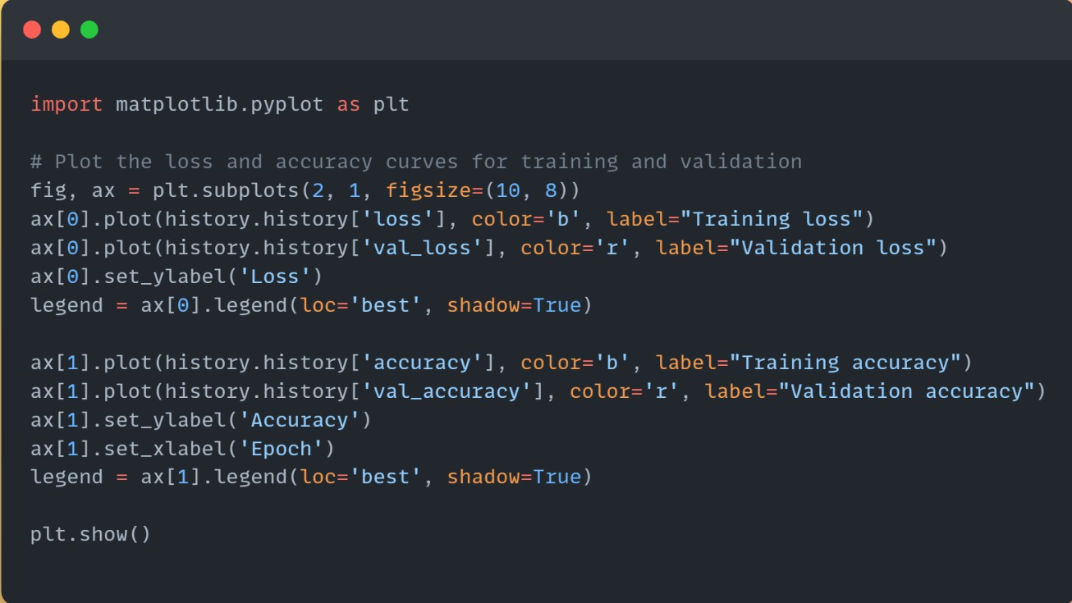
Fig 23: Function to plot Accuracy and Loss v/s Epoch

This code (Fig 23) employs Matplotlib to generate two subplots that display the training and validation loss (top plot) and training and validation accuracy (bottom plot) over epochs. It retrieves the loss and accuracy history from a a trained model and plots it with blue lines for
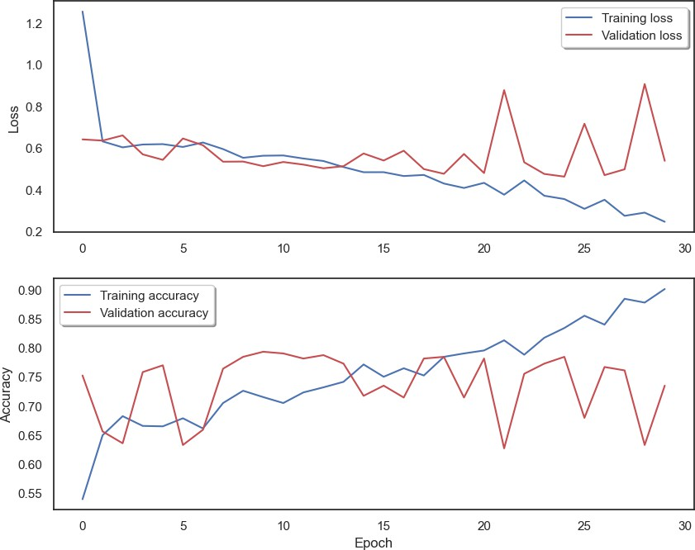
training and red lines for validation. The graphs as shown in Fig 24 helps visualize the model's performance during training by demonstrating how loss drops and accuracy improves over epochs.
Fig 24: Accuracy and Loss v/s Epoch graphs

      - Training and validation loss and accuracy graphs: Continual decrease in training loss and initial decrease of validation loss but then gradual increase is a sign of overfitting.
      - The validation accuracy starts to decrease while the training accuracy continues to increase which is also a sign of overfitting.

The “plot_confusion_matrix” function (Fig 25) generates a visual representation of a confusion matrix. It employs matplotlib to create a color-coded matrix, with each cell representing the number of true positives, false positives, true negatives, and false negatives. This function accepts the confusion matrix cm and a list of classes as input, together with optional parameters for normalization, title, and colormap. It then presents the confusion matrix, which includes
labels for true and predicted labels, making it easier to interpret the performance of a classification model.

The confusion matrix (Fig 26) generated from the “plot_confusion_matrix” function is explained below:
      - True Positive (TP): These are the cases where the model predicted the class as positive (P), and the actual class is also positive. In this case, TP = 92, which means there were 92 instances where the model correctly predicted the positive class.
      - True Negative (TN): These are the cases where the model predicted the class as negative (N), and the actual class is also negative. TN = 166, indicating that there were 166 instances where the model correctly predicted the negative class.
      - False Positive (FP): These are the cases where the model predicted the class as positive (P), but the actual class is negative (N). FP = 56, meaning there were 56 instances where the model incorrectly predicted the positive class.
      - False Negative (FN): These are the cases where the model predicted the class as negative (N), but the actual class is positive (P). FN = 30, indicating that there were 30 instances where the model incorrectly predicted the negative class.

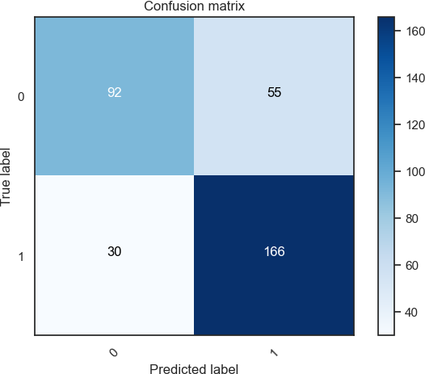
Fig 26: Confusion matrix


Fig 30: User-Interface for copy-move forgery detection

CHAPTER 6: CONCLUSIONS AND FUTURE SCOPE

CONCLUSION
In this project, the two models utilized to detect weather the images have copy-move forgery or splicing forgery with the help of 2 separate CNN models. Commencing with the input image, the system generates an ELA image, highlighting regions of interest through a comparison with re-shaped version. Subsequently, features, encompassing texture and color information, are extracted from the ELA image. With a precision rate of 89% for the copy-move forgery and 75% for the splicing forgery detection the web interface is able to efficiently predicts both the type of forgery.

FUTURE SCOPE
    - Dataset Expansion and Complexity: Enlarge the dataset with diverse forgery scenarios, resolutions, and compression levels to strengthen the model's capability to detect a broader range of manipulations.
    - The model can also be upgraded to detect more types of image forgeries such as Image resampling and Image retouching.
    - Interdisciplinary Collaborations: Collaborate with fields like cryptography and blockchain to explore image authentication and tamper-proofing solutions, enhancing image integrity and traceability.
    - Advanced Machine Learning Integration: Incorporate advanced machine learning algorithms, like deep learning models, to enhance accuracy in detecting complex manipulations and improve adaptability.

